HASH FUNCTIONS AND DIGITAL SIGNATURE

1. MD5 HASH FUNCTION
Aim
To implement the MD5 hash function and generate a fixed-length hash value for a user-given message.
Algorithm
- Start the program.
- Import the hashlib library.
- Get a message from the user using input().
- Convert the message into bytes using encode().
- Apply the MD5 hashing algorithm.
- Convert the hash into hexadecimal format using hexdigest().
- Display the original message and MD5 hash.
- Stop the program.
Code
import hashlib

message = input("Enter the message: ")

hash_value = hashlib.md5(message.encode()).hexdigest()

print("Original Message:", message)
print("MD5 Hash:", hash_value)

OUTPUT:
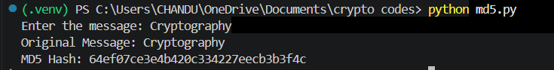
Explanation
The program reads a message from the user and converts it into bytes. The hashlib.md5() function generates the MD5 hash, and hexdigest() displays the result as hexadecimal characters.
MD5 produces a 128-bit hash, normally represented by 32 hexadecimal characters. MD5 is useful for learning hashing, but it is not recommended for modern security applications because practical collision attacks exist.

2. SHA-512 HASH FUNCTION
Aim
To implement the SHA-512 hash function and generate a secure hash value for a user-given message.
Algorithm
- Start the program.
- Import the hashlib library.
- Read a message from the user.
- Convert the message into bytes.
- Apply the SHA-512 hashing algorithm.
- Convert the result into hexadecimal format.
- Display the original message and SHA-512 hash.
- Stop the program.

Code
import hashlib

message = input("Enter the message: ")

hash_value = hashlib.sha512(message.encode()).hexdigest()

print("Original Message:", message)
print("SHA-512 Hash:", hash_value)

OUTPUT:

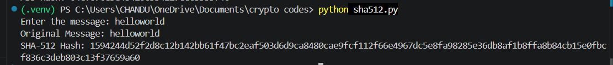
Explanation
SHA-512 is part of the SHA-2 family. It generates a 512-bit hash, which is represented by 128 hexadecimal characters. Even a small change in the input normally produces a completely different hash value.
SHA-512 is suitable for cryptographic hashing where a strong modern hash function is required.

3. SIMPLE USER-DEFINED HASH FUNCTION
Aim
To implement a simple user-defined hash function and generate a hash value for a message entered by the user.
Algorithm
- Start the program.
- Define a simple hash function.
- Initialize the hash value to zero.
- Read the message from the user.
- Process each character of the message one by one.
- Find the ASCII value of each character using ord().
- Update the hash using the formula (hash × 31 + ASCII value) mod 100000.
- Return and display the final hash value.
- Stop the program.
Code
def simple_hash(message):
hash_value = 0

for character in message:
hash_value = (hash_value * 31 + ord(character)) % 100000

return hash_value

message = input("Enter the message: ")

result = simple_hash(message)

print("Original Message:", message)
print("Hash Value:", result)

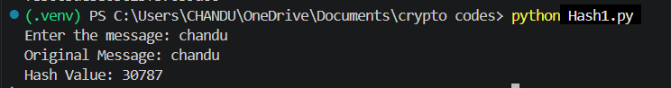
Explanation
The program starts the hash value at zero. It then reads every character and obtains its ASCII value. The hash is updated using a multiplication factor of 31 and a modulo operation to keep the value within the selected range.
This program is only an educational demonstration of the basic idea of hashing. It is not a secure cryptographic hash algorithm and should not be used for passwords, digital signatures or security-critical applications.
4. DIGITAL SIGNATURE USING RSA AND SHA-256
Aim
To implement a digital signature using RSA and SHA-256 and verify the authenticity and integrity of a user-given message.
Algorithm
- Start the program.
- Generate an RSA private key.
- Generate the corresponding RSA public key.
- Read the message from the user.
- Create a digital signature using the private key and SHA-256.
- Display the original message and generated signature.
- Verify the signature using the public key.
- If verification succeeds, display SUCCESS.
- Otherwise, display FAILED.
- Stop the program.
Code
from cryptography.hazmat.primitives.asymmetric import rsa, padding
from cryptography.hazmat.primitives import hashes

# Generate RSA private key
private_key = rsa.generate_private_key(
public_exponent=65537,
key_size=2048
)

# Generate public key
public_key = private_key.public_key()

# Get user input
message = input("Enter the message: ").encode()

# Create digital signature
signature = private_key.sign(
message,
padding.PSS(
mgf=padding.MGF1(hashes.SHA256()),
salt_length=padding.PSS.MAX_LENGTH
),
hashes.SHA256()
)

print("
Original Message:", message.decode())
print("Digital Signature:", signature.hex())

# Verify digital signature
try:
public_key.verify(
signature,
message,
padding.PSS(
mgf=padding.MGF1(hashes.SHA256()),
salt_length=padding.PSS.MAX_LENGTH
),
hashes.SHA256()
)

print("Signature Verification: SUCCESS")
print("Message is authentic and unchanged.")

except Exception:
print("Signature Verification: FAILED")
print("Message may have been modified.")
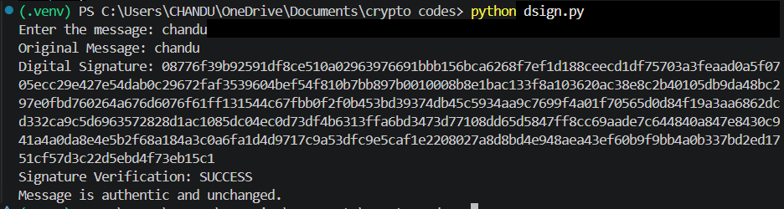
Explanation
The sender first generates an RSA key pair consisting of a private key and a public key. The message is signed using the private key and SHA-256 with RSA-PSS.
The receiver can verify the signature using the public key. If the verification succeeds, the signature matches the message and the corresponding private key. If the message is changed after signing, verification will fail.
The displayed signature is different each time because RSA-PSS uses randomization. Therefore, the exact hexadecimal signature shown during your run will not necessarily match the sample output.

